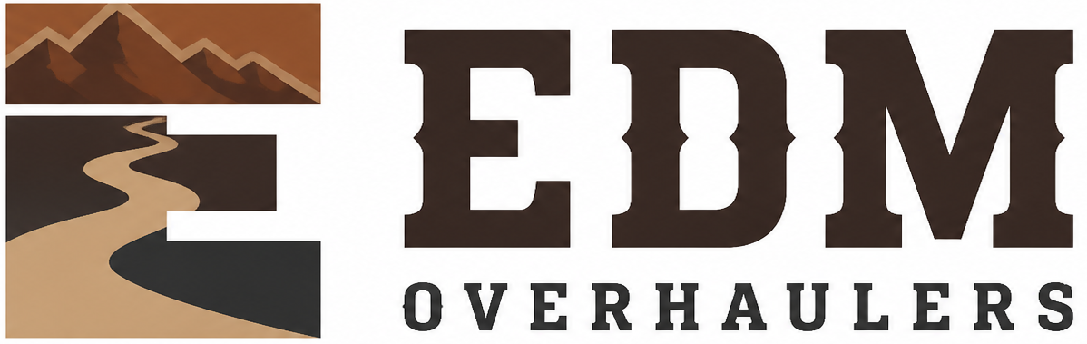

Confidentiality and Data Access Agreement
  - EDM Overhaulers
Editable adaptation draft • September 15, 2026 • Not adopted or executed
EDM’s trailer repair and refurbishment work connects customer approvals, parts, hands-on work and the care of vehicles held for a job. Keep the scope, photographs, costs and completion evidence together in the job folder.
In this draft, “Company” means EDM Overhaulers. Complete the Owner Setup and Tailoring Checklist before adoption or signing. California source provisions require an applicability check for the actual work locations. This draft does not establish employment, insurance or legal status.

Parties and access
Field | Entry
Person legal name and relationship
Approved systems and records
Approved business purpose
Effective date
Review date
Access end date

Agreement
I will use the Company’s confidential information only for the approved business purpose and share it only with approved recipients.
I will store Company records in the approved location and follow the Information Security, Device, Access, and Records Policy.
I will protect customer, financial, tax, personnel, identity, contract, credential, and business information from unauthorized access or disclosure.
I will report a lost record, misdirected message, exposed credential, suspicious login, or unauthorized access immediately.
At the end of access, I will return Company records and property, remove approved local copies as directed, and confirm completion.
These duties continue after access ends for information that remains confidential by law or agreement.

Signatures
Signature: ____________________________________ Date: __________________
Person receiving access
Name and relationship
Signature: ____________________________________ Date: __________________
[Authorized manager]
Manager
Source: CSG_Confidentiality_and_Data_Access_Agreement.docx. Adapted from retained CSG work; original unchanged. See the owner checklist. This is not legal advice.

