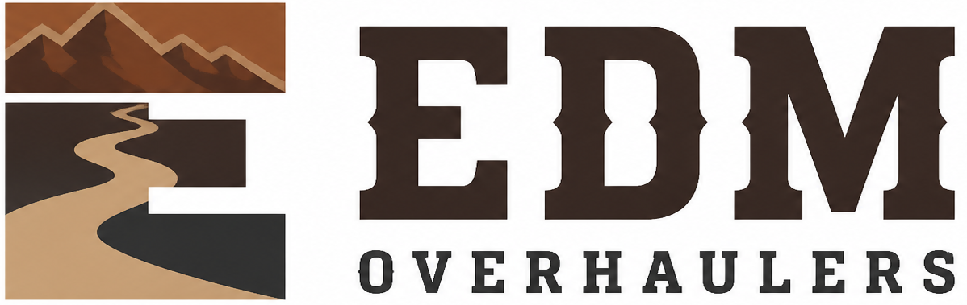

Employee Policy Acknowledgment
  - EDM Overhaulers
Editable adaptation draft • September 15, 2026 • Not adopted or executed
EDM’s trailer repair and refurbishment work connects customer approvals, parts, hands-on work and the care of vehicles held for a job. Keep the scope, photographs, costs and completion evidence together in the job folder.
In this draft, “Company” means EDM Overhaulers. Complete the Owner Setup and Tailoring Checklist before adoption or signing. California source provisions require an applicability check for the actual work locations. This draft does not establish employment, insurance or legal status.

Employee and issue record
Field | Entry
Employee legal name
Job title
Start date
Worksite
Handbook version/date received
IIPP training date
WVPP training date
Information-security policy received
Equipment/access forms attached

Acknowledgment
I received the documents and training listed above. I understand how to report payroll, leave, safety, workplace-violence, harassment, data-security, access, and equipment concerns. I will follow the policies and written work instructions and ask the Manager when I need clarification.

Signatures
Signature: ____________________________________ Date: __________________
Employee
Legal name
Signature: ____________________________________ Date: __________________
[Authorized manager]
Manager
Source: CSG_Employee_Policy_Acknowledgment.docx. Adapted from retained CSG work; original unchanged. See the owner checklist. This is not legal advice.

