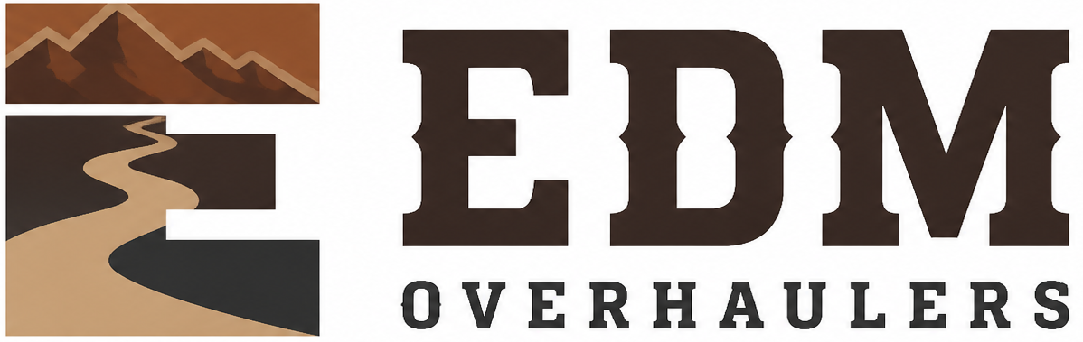

Equipment Custody and Return Agreement
  - EDM Overhaulers
Editable adaptation draft • September 15, 2026 • Not adopted or executed
EDM’s trailer repair and refurbishment work connects customer approvals, parts, hands-on work and the care of vehicles held for a job. Keep the scope, photographs, costs and completion evidence together in the job folder.
In this draft, “Company” means EDM Overhaulers. Complete the Owner Setup and Tailoring Checklist before adoption or signing. California source provisions require an applicability check for the actual work locations. This draft does not establish employment, insurance or legal status.

Equipment record
Field | Entry
Recipient legal name and relationship
the Company asset ID
Manufacturer/model
Serial number
Accessories
Condition at issue
Issue date
Approved use/project
Return date or trigger
Original purchase/source record

Recipient agreement
I accept the equipment in the recorded condition and will use it for the approved work.
I will protect it from loss, damage, theft, unauthorized use, and unauthorized data transfer.
I will follow the Company security, safety, maintenance, and record-handling requirements and report an incident immediately.
I will return the equipment, accessories, and Company records on the stated date or when the Company requests return.

Signatures
Signature: ____________________________________ Date: __________________
Recipient
Name and relationship
Signature: ____________________________________ Date: __________________
[Authorized manager]
Manager
Source: CSG_Equipment_Custody_and_Return_Agreement.docx. Adapted from retained CSG work; original unchanged. See the owner checklist. This is not legal advice.

